Andrew Mayak
Professor Yang
CMPSC 132
March 4, 2025

Project- 1
- Description of the project
  - This is a project that implements a shopping cart system for an e-commerce platform. This utilizes advanced object-oriented programming concepts. This is composed of eight implemented classes:
    - Product Class
    - Digital Product Class
    - Physical Product Class
    - Cart Class
    - User Class
    - Discount Class
    - Percentage Discount Class
    - Fixed Amount Discount Cass
  - This Project implements the main object-oriented principles which are:
    - encapsulation,
    - polymorphism
    - abstraction
    - inheritance

- Structure of the code with diagram and some comments regarding structure
  - Block diagram or flow chat which shows the overall structure of your implementation
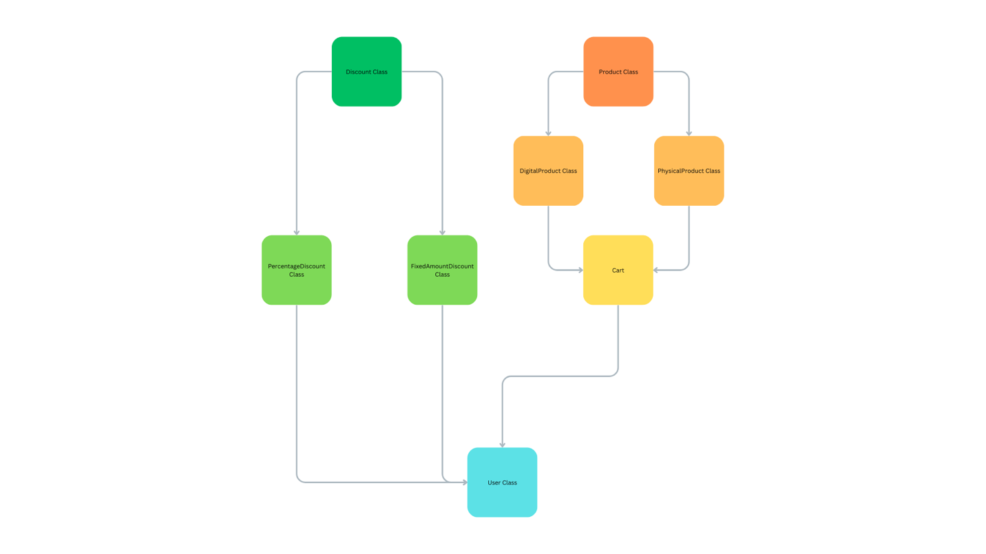

  - Here is a summary of the eight classes
      - Product Class – This creates product with general attributes
      - DigitalProduct Class - This creates digital product, including Product class attributes along with digital attributes
      - PhysicalProduct Class- This creates physical product, including Product class attributes along with physical attributes
      - Cart Class – This takes the DigitalProduct and PhysicalProduct Classes and adds whichever objects of either class and can add them to a list called “cart” or “__cart_items”
      - User Class – This uses the Cart Class attributes and allows the checking out of products and applying of discount to the products.
      - Discount Class – This creates base for other classes using the Discount class since it is being an abstract class.
      - PercentageDiscount Class- This uses the Discount Class to create PercentageDiscount Objects.
      - FixedAmount Discount Class - This uses the Discount Class to create FixedAmountDiscount Objects.

- Instructions
  - You can create objects using Product, DigitalProduct and PhysicalProduct. DigitalProduct and PhysicalProduct must be defined with the same attributes as the Product class since both classes inherit from the Product class (All of the classes mentioned from now on need the attributes listed to be defined as an object unless if it is said to be defined elsewhere). Additional attributes are required for the DigitalProduct and PhysicalProduct classes respectively. This therefore implements the concept of inheritance.
  - The Product class has the attributes:
    - product_id
    - name
    - price
    - quantity
  - The DigitalProduct class has the additional attributes:
    - file_size
    - download_link
  - The PhysicalProduct class has the additional attributes:
    - Weight
    - Dimensions
    - shipping_cost
  - These classes uses this method:
    - get_product_info() - prints all of the attributes of any of Product classes (the first word before the period needs to the class name.)
      - Command example: Product. get_product_info(item1)
    - Creating objects uses all of these attributes:
      - Object creation examples:
        - For Product class:
          - item1 = Product(id("Toy"),"Toy",12.99,1344)
        - For PhysicalProduct class:
          - Pitem1 = PhysicalProduct(id("Water Bottle"),"Water Bottle" ,1.99,1243423, "0.5 Lb" , "1x1x1 mm", "10.99")
        - For Digital class:
          - Ditem1 = DigitalProduct(id("Feather Hat Image"),"Feather Hat Image",99.99,231,"1.2GB", "https:freehats.org" )

  - The Cart class can receive any of the previously mentioned classes. It can add products into a private list named __cart_items using encapsulation. It can also create an object with this class.
  - The Cart class uses the attributes:
    - __cart_items (This is not needed to define Cart class)
    - product_id (This is attribute in any of the classes with “Product” in their names. It is referenced in a method.)
    - product (This refers to any object of any of the classes with “Product” in their names. It is referenced in a method and not defined in an object.)
  - This class uses these methods:
    - add_product(product) – This adds product to the private list: __cart_items. It also prints what item is added to the __cart_items (referred to as Cart).
      - Command example: cart1. add_product(obj1)
    - remove_product() – This removes product from provate list: __cart_items. Also prints what item is removed from __cart_items (referred to as Cart).
      - Command example: cart1. remove_product (obj1)
    - view_cart() – This prints all of the items in the Cart (also known as the __cart_items list).
      - Command example: cart1. view_cart()
    - clear_cart() – This clears all of the contents of the __cart_items list.
      - Command example: cart1. clear_cart()

  - The User class creates user as an object. Uses attributes from the Cart class
  - The User class uses the attributes:
    - user_id
    - name
    - cart (references the Cart() class)
  - This class uses these methods:
    - add_to_cart(product) – This adds product to provate list: __cart_items using the Cart() class
      - Command example: User1.add_to_cart(Pitem1)
    - remove_from_cart() – This removes product from provate list: __cart_items using the Cart() class. It Requires product_id.
      - Command example: User1.remove_from_cart(Pitem1.product_id)
    - checkout() – This prints the User is checking out, applies discounts to the total of the cart, and clears the cart items.
      - Command example: User1.checkout()

  - The Discount class creates user as an object. This is an Abstract class
  - The Discount class uses the attributes:
    - Total_amount
    - Percentage
  - This class uses these methods:
    - apply_discount(total_amount) – This applies discount to the total amount owed for the cart.
  - No commands can be used to access for this class since it is and)

  - The PercentageDiscount class creates user as an object. This inherits from the Discount class
  - The PercentageDiscount class uses the attributes:
    - Total_amount
    - percentage
  - Creating objects uses all of these attributes:
    - Object creation example:
      - discount1 = PercentageDiscount(1000, 0.10)
  - This class uses these methods:
    - apply_discount(total_amount) – This applies discount to the total amount owed for the cart. This prints out the total before and after applying discount (total_amount needs to be specified before calling method).
      - Command example: discount1.apply_discount(1000)

  - The FixedDiscount class creates user as an object. This inherits from the Discount class.
  - The FixedDiscount class uses the attribute:
    - amount
  - Creating objects uses this attribute:
    - Object creation example:
      - discount1 = FixedDiscount(200)
  - This class uses these methods:
    - apply_discount(amount) – This applies discount to the total amount owed for the cart. This prints out the total before and after applying discount (amount needs to be specified).
      - Command example: discount1.apply_discount(1000)

  - Proof of the sanity of the code to check the validity of the implemented functionalities(All Screenshots).

